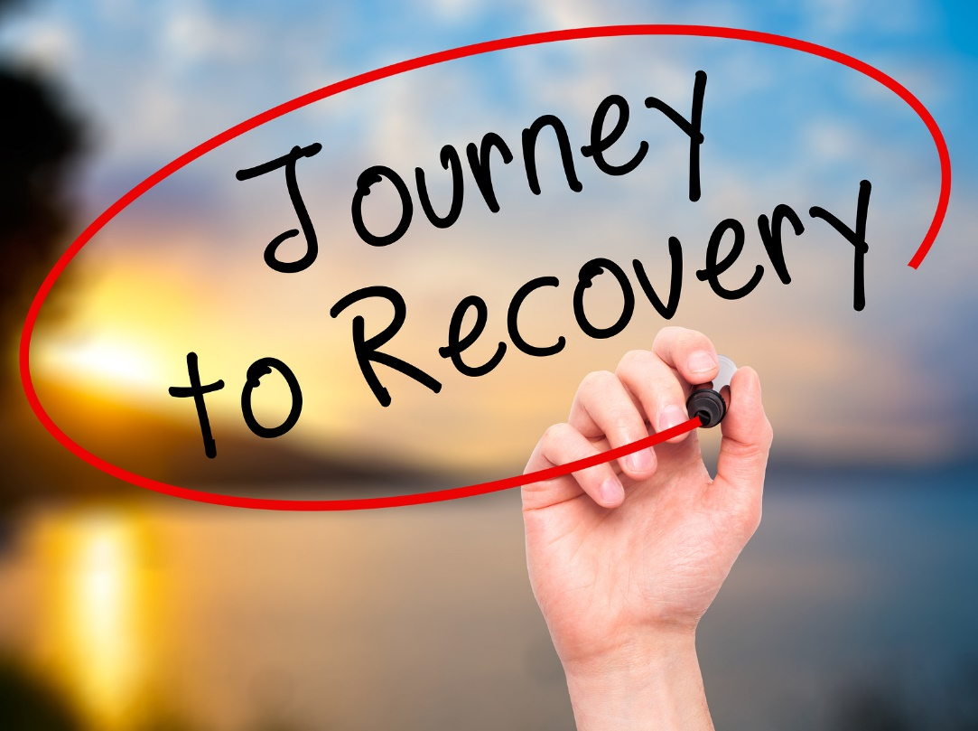  ANNOUNCING  SafeSpace Delaware (SSDE)  (Formerly RVRC)  As part of re-branding our image and mission, we present to the public, “SafeSpace Delaware (SSDE)”. As in recovery, individuals begin an arduous journey of life changing processes, SafeSpace DE is beginning a new chapter by revising, enhancing, and improving our image and broadening our mission.  Mission Statement: The mission of SafeSpace Delaware is to provide a safe environment and restore hope and stability to the most vulnerable and underserved.  Program Focus: SafeSpace Delaware’s programs and services focus on adults who are homeless, at risk of being homeless, and adults dealing with mental health, substance use, and co-occurring disorders.  Values: Caring, Empathy, Trust & Transparency  Recovery Month, as a part of recognizing this annual event, SafeSpace Delaware and SODAT Delaware will co-host their seventh annual Recovery Month Rally. The purpose of our annual event is to increase the awareness of substance abuse, mental health treatment, recovery and available resources.  We are joining forces with the national theme, “Join The Voices for Recovery, Invest in Health, Home, Purpose, & Community”. In the news, we hear how Opioid use has become an epidemic. Reports of drug related crime, violence and death is affecting Wilmington and communities nationwide. Please join us on September 28, 2018 from 9:00 am to 5:00 pm in offering, “A MESSAGE OF HOPE” to those still suffering and struggling with active addiction, untreated mental health and homelessness!!!!!!!  SSDE @ 500 W. 2nd Street, Wilmington, DE 302-691-7946 x 107 | SEPTEMBER 28, 2018  SafeSpace DelawaRE (SSDE) (Formerly RVRC)  RECOVERY DAY RALLY  12 STEP MEETINGS  ────  KEYNOTE SPEAKER  ────  ENTERTAINMENT  ────  FOOD  ────  MUSIC  ────  RAFFLE TICKETS  ────  PRIZES  ────  COMMUNITY VENDORS  ────  TALENT SHOW & PRIZE MONEY  CALL TO SIGN UP 302 691-7946 X 107 ASK FOR RICKIE  500 WEST 2ND STREET  WILMINGTON, DELAWARE 19801

